Name: _________________________________ Core : _______________
Topic 1B Review
Examples Questions/Problems
(Do these!)
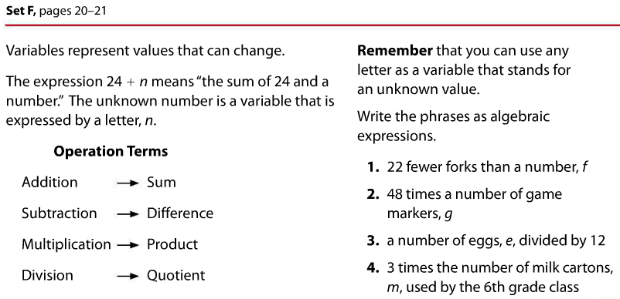

Turn the paper over. Do that side, too.

Examples Questions/Problems
