Text Page 54 Bronze
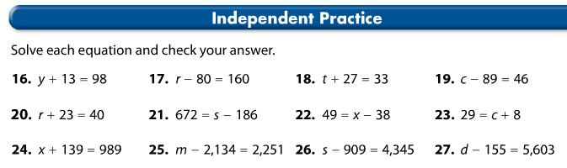

__________________equation
__________________ inverse op.
__________________ solution
__________________ check

_________________equation
__________________ inverse op.
__________________ solution
__________________ check

__________________equation
__________________ inverse op.
__________________ solution
__________________ check

__________________equation
__________________ inverse op.
__________________ solution
__________________ check

_________________equation
__________________ inverse op.
__________________ solution
__________________ check

__________________equation
__________________ inverse op.
__________________ solution
__________________ check

__________________equation
__________________ inverse op.
__________________ solution
__________________ check

_________________equation
__________________ inverse op.
__________________ solution
__________________ check

__________________equation
__________________ inverse op.
__________________ solution
__________________ check

__________________equation
__________________ inverse op.
__________________ solution
__________________ check

_________________equation
__________________ inverse op.
__________________ solution
__________________ check

__________________equation
__________________ inverse op.
__________________ solution
__________________ check

