Name ___________________ Period ______ Date____________

Topic 1A Quiz 1 Review Sheet
EXAMPLES DO THESE
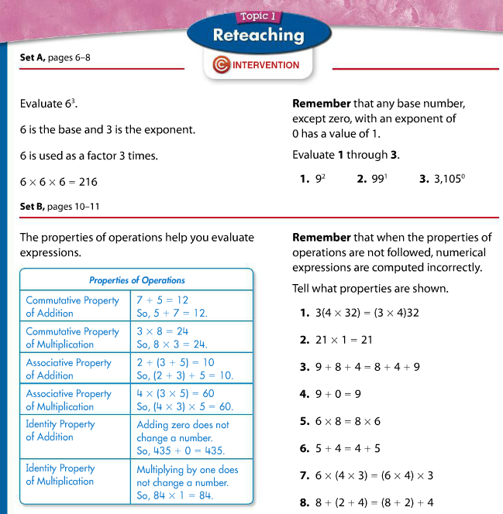

Show all of the steps.
