Name _______________________________ Period ______ Date______
Topic 1A Review (2-sides)
Name the properties and fill in the blanks.
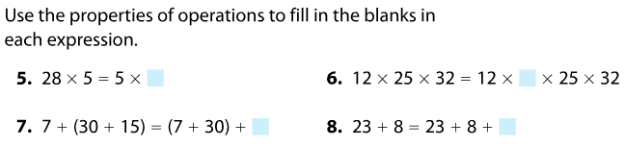

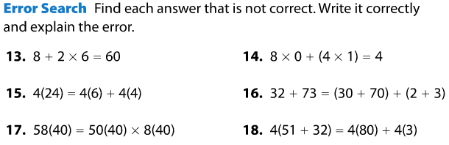

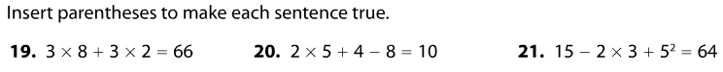

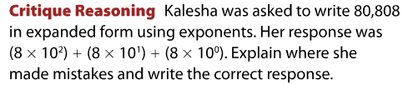

Evaluate each expression. Show each step and your work.
Order Computation

