Topic 9 Study Guide
- A quidditch team has a boy to girl ratio of 4 to 3. Which of the following is equal to this ratio:

- 12 boys to 15 girls b) 16 girls to 12 boys
c) 16 boys to 12 girls d) 8 boys to 9 girls

- The table shows the relationship between Jenny’s earnings and the hours she worked. What is the missing value in the table?
Earnings ($) | 15 | 30 | 45 | ? | 75.00
Hours | 2 | 4 | 6 | 8 | 10

- The table shows the medals won by the U.S. at the 2004 Summer Olympics in Athens, Greece. What is the ratio of bronze medals won to the total number of medals won by the U.S.?

Gold | Silver | Bronze
36 | 39 | 27

- Which number is missing from the table of equivalent ratios?
5 | 10 | 15 | 45 | 60
3 | 6 | 9 | ? | 36

- Two garbage cans are needed for every 8 students cleaning out their lockers. How many garbage cans will be needed if there are 56 students cleaning out their lockers? Use the tape diagram below to help you find the answer.

? garbage cans

56 students

- Julie is making a necklace. She used 8 blue beads and 12 purple beads to make the necklace. Write a ratio that compares the number of purple beads to the total number of beads in the necklace.

- The diagram shows the angle measures of a right triangle. What is the ratio of the measure of angle A to the measure of angle B?
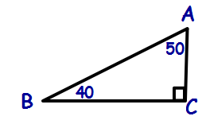

- James solved 3 math problems in 7 minutes. How long will it take him to solve 12 math problems?
Problems | 3 | 6 | 9 | 12 | 15
Minutes | 7 | 14 | 21 | ? | ?

- What number makes the two ratios form a proportion?
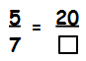

- A school has a ratio of basketball trophies to volleyball trophies of 3:2. What fraction of the trophies are volleyball trophies?
Basketball trophies
Volleyball trophies

- Teegan uses 1 cup of milk for each batch of 12 muffins she bakes. How many muffins can she bake with a quart of milk (one quart = 4 cups).

- In simplest form, what is the ratio of x:y shown on the graph?
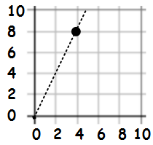
- In order to make a yummy snack, Lucas mixed 12 tablespoons of M&Ms with 1 cup (16 tablespoons) of pretzels. What is the simplest form of the ratio of M&Ms to pretzels?

- The ratio of girls to boys in the band is 6:5. If there are 42 girls in the band, how many students are in the band?

